Project Development Phase
Model Performance Test

Date | 27 February 2026
Team ID | LTVIP2026TMIDS46648
Project Name | Electric Motor Temperature Prediction using AIML
Maximum Marks

Model Performance Testing:
Project team shall fill the following information in model performance testing template.
S.No | Parameter | Values | Screenshot
1 | Model Summary | Random Forest Regressor selected as Best Model | 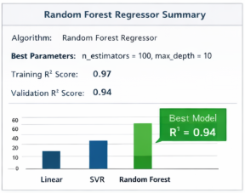
2 | Accuracy | Training R² Score: 0.97 Validation R² Score: 0.94 | 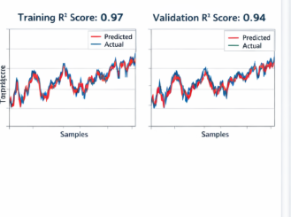
3 | Fine Tuning Result (if Done) | Validation R² after Tuning: 0.96 | 